BRAC UNIVERSITY
Department of Computer Science and Engineering

Examination: Semester Midterm  Duration: 1 hour 10 min | Semester: Summer 2023  Full Marks: 30
CSE 320: Data Communications

Answer the following questions.
Figures in the right margin indicate marks.

SET A

Name: | ID: | Section:

1.  [CO1] | a) | Suppose there are 4 buildings in BRACU’s new campus. Buildings are connected using bus topology. Each building has 3 CSE Labs. Each Lab has 4 computers. The computers are connected using mesh topology but the Labs of a single building are connected using star topology. Draw the BRACU new campus hybrid topology. How many links will there be (links are using full-duplex transmission mode)? | [5]
 | b) | Identify the name of the TCP/IP model layers based on the following functionalities.  - Enables resource sharing and remote file access among network users.  - Responsible for converting data into signals for transmission over a physical medium.  - Responsible for establishing and terminating communication sessions.  - Ensure reliable hop to hop transmission. | [2]
 | c) | Identify at least 2 differences amongst logical, physical and port addresses. Explain with an example why all these addresses are needed? | [3]
2.  [CO2] | a) | 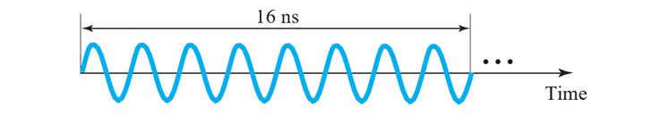  Figure 2.a: Analog Signal (time Vs Amplitude)  In the above Figure 2.a, determine the time period and frequency of the analog signal. Also show the frequency domain representation of the signal if the maximum amplitude is 20V. | [3]
 | b) | Suppose the signal power is 5 MW at point A. The power loss rate at the wire from A to B is 5 kW/km and from C to D is 0.05 dB/km. Calculate the total change of signal power in decibel and comment if the power is being amplified/attenuated.  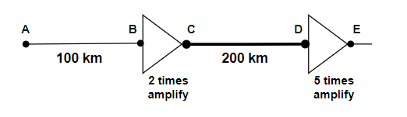 | [3]
 | c) | Consider a communication channel that requires to send 108 GB within 6 hours. The link operates on signals with frequency range from 900 KHz to 14 MHz. If the link is perfect, i.e., no noise is introduced in the link,  - Determine the number of voltage levels needed to fulfill the requirement.  - In practice, there is no noise free channel. Suppose, the strength of the noise power is 20mW which is 60 times weaker than the signal power. What will be the channel capacity considering the noise? | [2+2]
3.  [CO2] | a) | Two devices A and B are sending digital signals using the NRZ-I-line coding scheme. Device C is receiving the signal simultaneously and combining them using bitwise AND operation. Then produces the final digital signal using a line coding scheme that doesn’t have the consecutive 0 problem. Illustrate the final signal produced by C. [You can use any valid line coding scheme for C] [Draw it in the question paper only.]  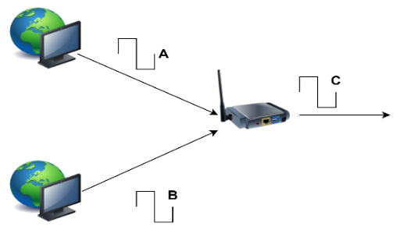  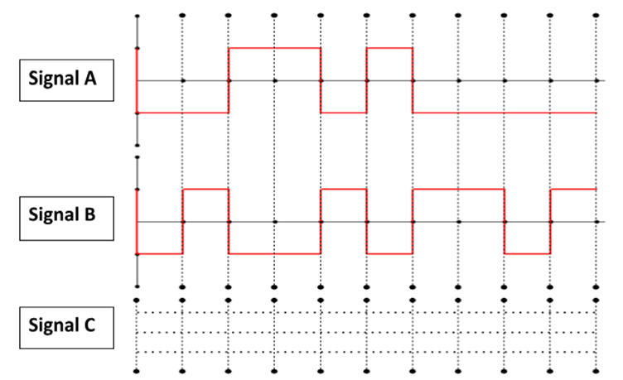 | [5]
 | b) | The following figure depicts a sampled analog signal for digital signal representation. By applying the concept of Pulse Code Modulation, assume there will be 3-bit code words for each sampled amplitude. Show the normalized Quantized value and quantization code for the given analog signal value at different time stamps. Assume that the sampling amplitudes are between -40V to +40V.  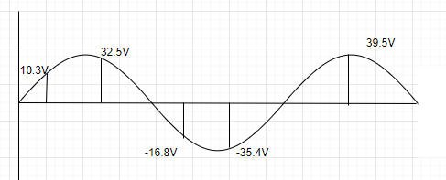 | [5]


